**Crystal Products e-Project**

**Documentation**

**Group Members**

* **Student1413666 ALABI ESTHER**
* **Student1382147 YISA ADEOLA**
* **Student1385947 KAZEEM OYINKANSOLA**
* **Student1275735 OLUWABAMISE BAKARE**

**Start-date: 21-06-2023**

**End-date: 27-06-2023**

**ACKNOWLEDGEMENT**

I would like to acknowledge all those who have given me moral support and helped in making the project a success.

Thanks to our teacher Mr. Obed Jonathan who helped and guided us during the project.

Also, I would like to express my gratitude to all the staff members of my centre for not only providing me the opportunity to work with them on this project, but also for their support and encouragement throughout the process.

I also express my sincere gratitude to e-Project Team from APTECH Head Office and my project guide at the organization for his valuable guidance and support for completion of this project.

Final, I would like to offer many thanks to all my colleagues for their Valuable suggestions and constructive feedback.

Sincerely,

Student: Alabi Esther

Student: Kazeem Oyinkansola

Student: Yisa Adeola

Student: Oluwabamise Bakare

**TABLE OF CONTENT**

* **Project Brief**
* Problem Statement
* Requirement Specification
* Hardware Requirement
* Software Requirement
* Project Synopsis
* Project Analysis
* Project Design
* Screenshot
* Source Code
* User Guide
* Developer’s Guide

**PROBLEM STATEMENT**

Today, people are drawn to crystals for a number of reasons, including primarily that they are very beautiful objects and their different shapes, sizes and colors have proved fascinating and mysterious as well. They can be found in various forms of beautiful jewelry, or on their own in rough uncut specimens that are sometimes used as ornaments to decorate homes.

Crystals are used to enhance the body’s own healing abilities, reduce stress and improve the quality of your life. They hold a massive amount of energy and those who work with them believe that they have their own individual, energy field or personality.

**Requirement Specification:**

The Web site is to be created based on the following requirements:

1. The Home Page should be created making use of Sections with a suitable logo, the header section can be added which will show images of various products.
2. The site must contain the links to navigate through any category for the information.
3. The site should display a menu which will contain the options for brief introduction about the various products available, location of the shop and any other information if required.
4. The information should be categorized according to the various crystals.
5. When a user selects any particular crystal, a list of all the products for that crystal will be displayed.
6. A brief summary of features of the product should be displayed on the Web Page along with the picture but detailed Features should be stored in Individual Word documents which can be downloaded or viewed by the User who wishes to see the same.
7. The user should also be able to compare the various products.
8. There should be a “Contact Us” page which will have the Address of the company which is as follows and the mail address which when clicked will invoke the local mail client from where they can send an email.

**HARDWARE / SOFTWARE REQUIREMENTS**

**Hardware/ Software Requirements**

**Hardware**

* A minimum computer system that will help you access all the tools in the courses is a Pentium 166 or better
* 64 Megabytes of RAM or better

**Software *[Either or Combination as per Course/Sem]***

* Notepad/HTML editor/CoffeeCup
* Angular / Angular JS / React / BootStrap
* Dreamweaver / Figma
* MS IE / Chrome / FireFox / Netscape /MS Edge

**Site Map**

* **HOME**
* **ABOUT US**
* **SPECIAL OFFERS**
* **NEW ARRIVALS**
* **PRODUCTS**
* **CONTACT US**

**PROJECT SYNOPSIS**

**Title:** E-commerce Crystal Product Website

**Problems & Solutions:** Crystal Product lacks the proposition to a website. We are expected to provide a website with a given specific requirements which are meant to be met, which also includes functionality on all browsers and a functional Geo-Location API. Crystal Products also provides special offers to their customers which also includes discount. We are to display the different and varieties of crystals on purchase and our new and latest arrivals.

**Aims & Objectives:** The aim and objective is for Crystal Products to be easily accessed by the users through the use of the web. Purchasing and buying of Crystals made easy and smooth just from the comfort of your home. We tend to make buying and purchasing of Crystals easy for our Users with the use of the web by just one click and that’s all. Crystal Product not only makes purchasing of Crystals easy but also provides information about each Crystals before making a purchase.

**CRYSTAL PRODUCTS** are used to enhance the body’s own healing abilities, reduce stress and improve the quality of one’s life. Our Crystals are also available in form of jewelry. They hold a massive amount of energy.

With the aid of a functional website for Crystal products users can:

* Buy Crystals at affordable prices
* Door-to-door delivery
* Internal and external recognition
* Varieties of crystals can be purchased
* Latest arrivals can be checked out
* Special offers can be made with a discount

**PROJECT ANALYSIS**

Crystals are used to enhance the body’s own healing abilities, reduce stress and improve the quality of one’s life. Our Crystal Products interact with the body’s energy field, creating balance and alignment. Our goal is to reach a wide range of users which is why this site was created. Users or purchasers of crystal can now check our available crystals and our latest and new arrivals by viewing our product page or the new arrivals page or ordering of the crystals after signing up on the page. For any information about our crystals or the site, users can visit our contact us page or query for any complaint.

**SCREENSHOT**

**HOME PAGE**

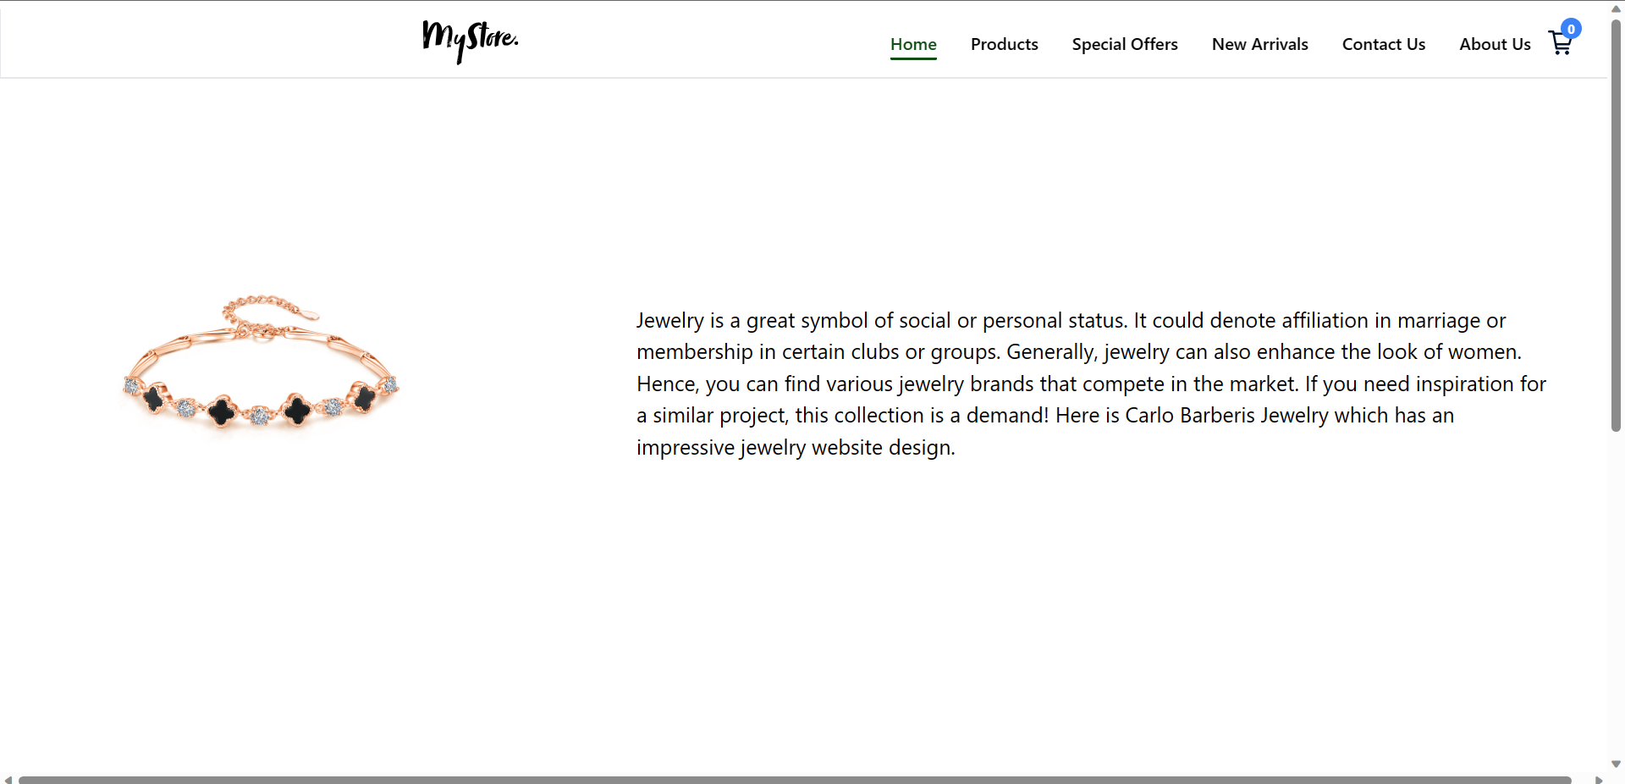

**HOME PRODUCT**

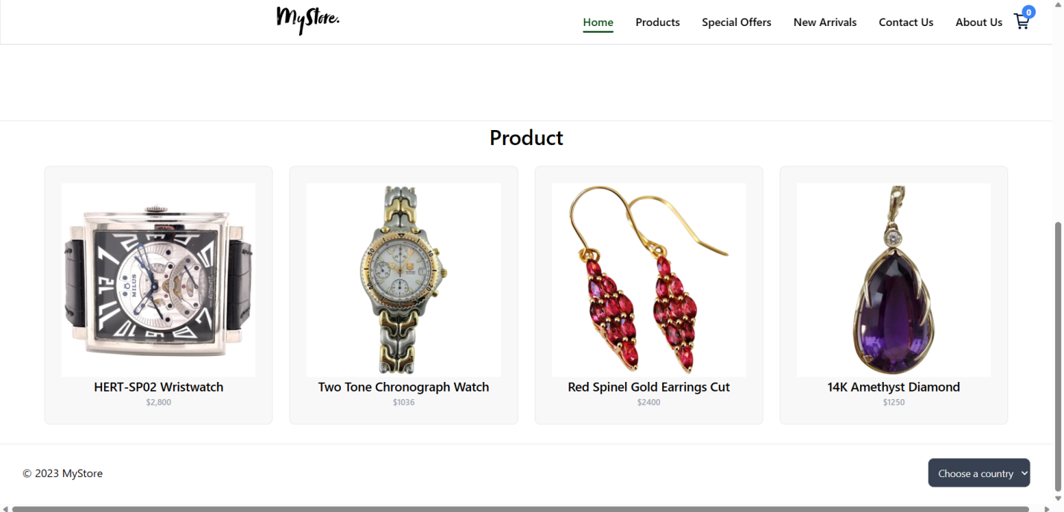

**PRODUCT PAGE**

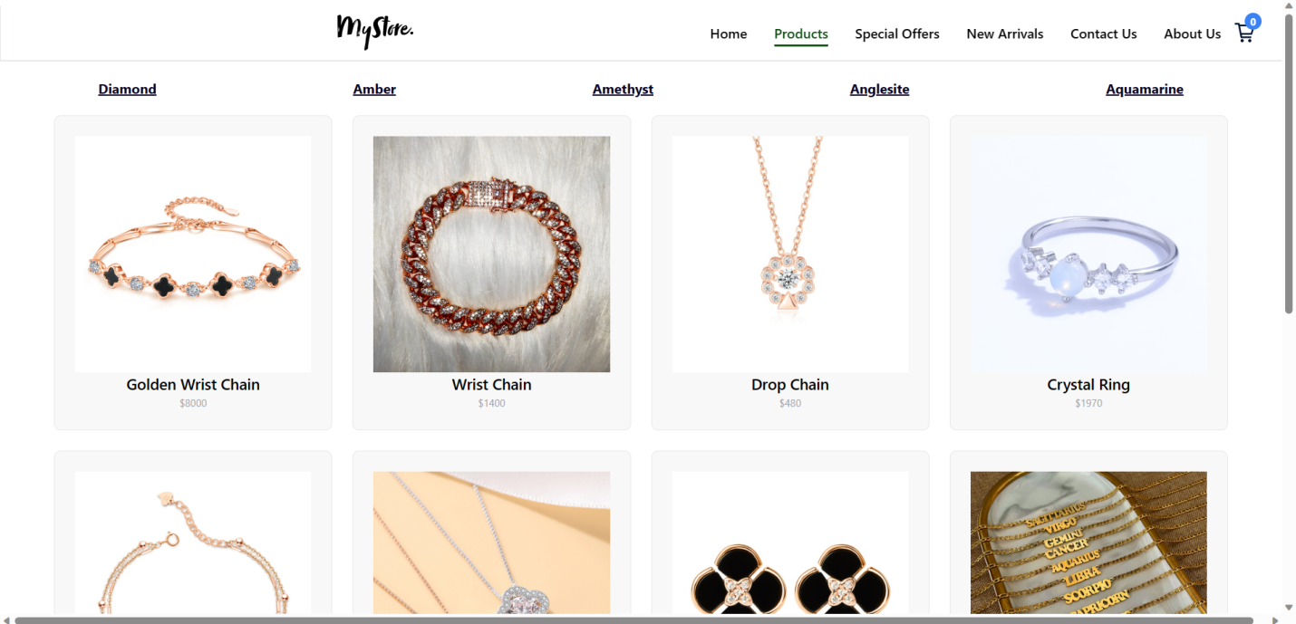

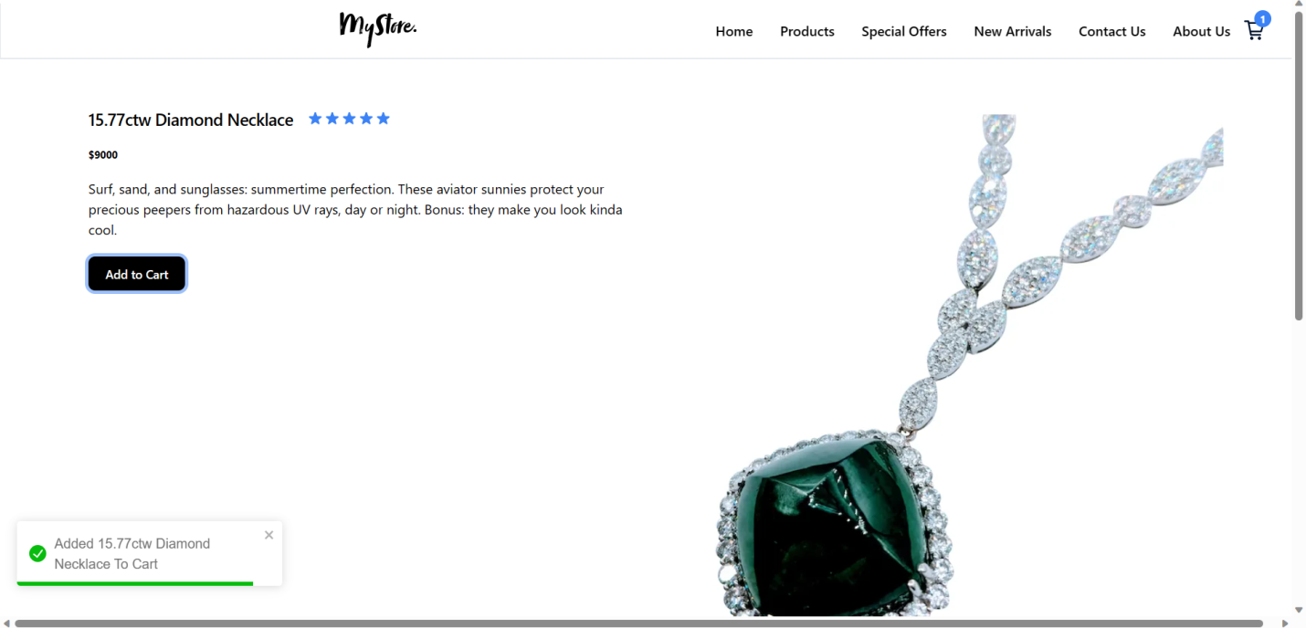

**AMBER AND AMETHYST PRODUCT PAGE**

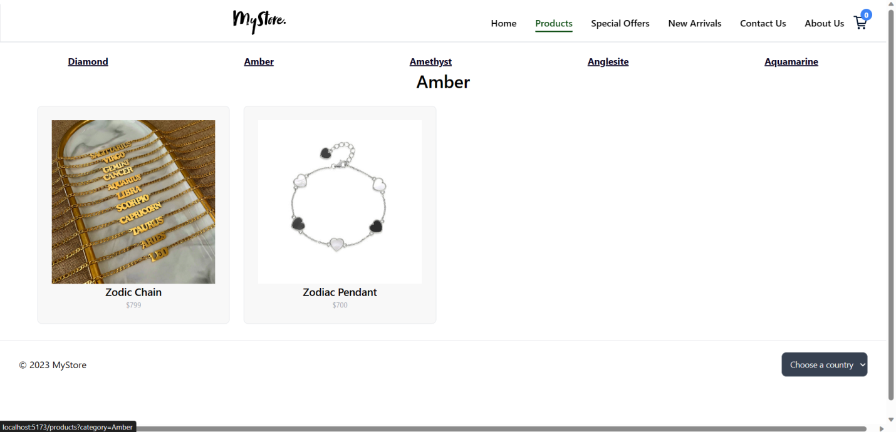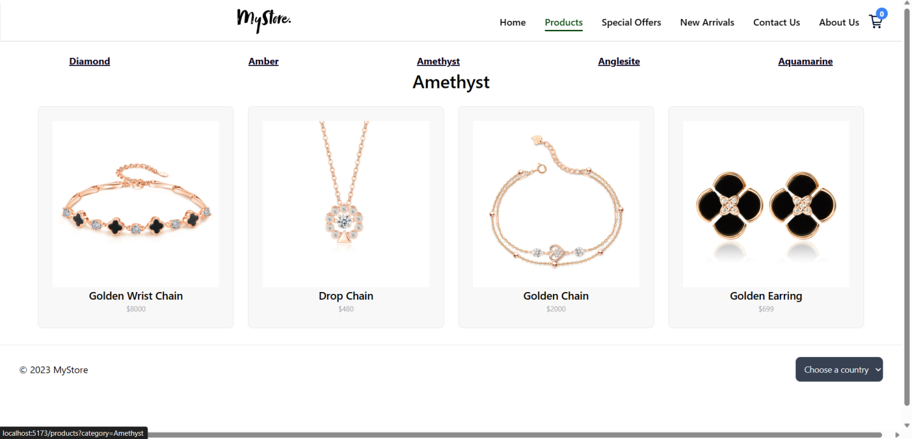

**AQUAMARINE AND DIAMOND PRODUCT PAGE**

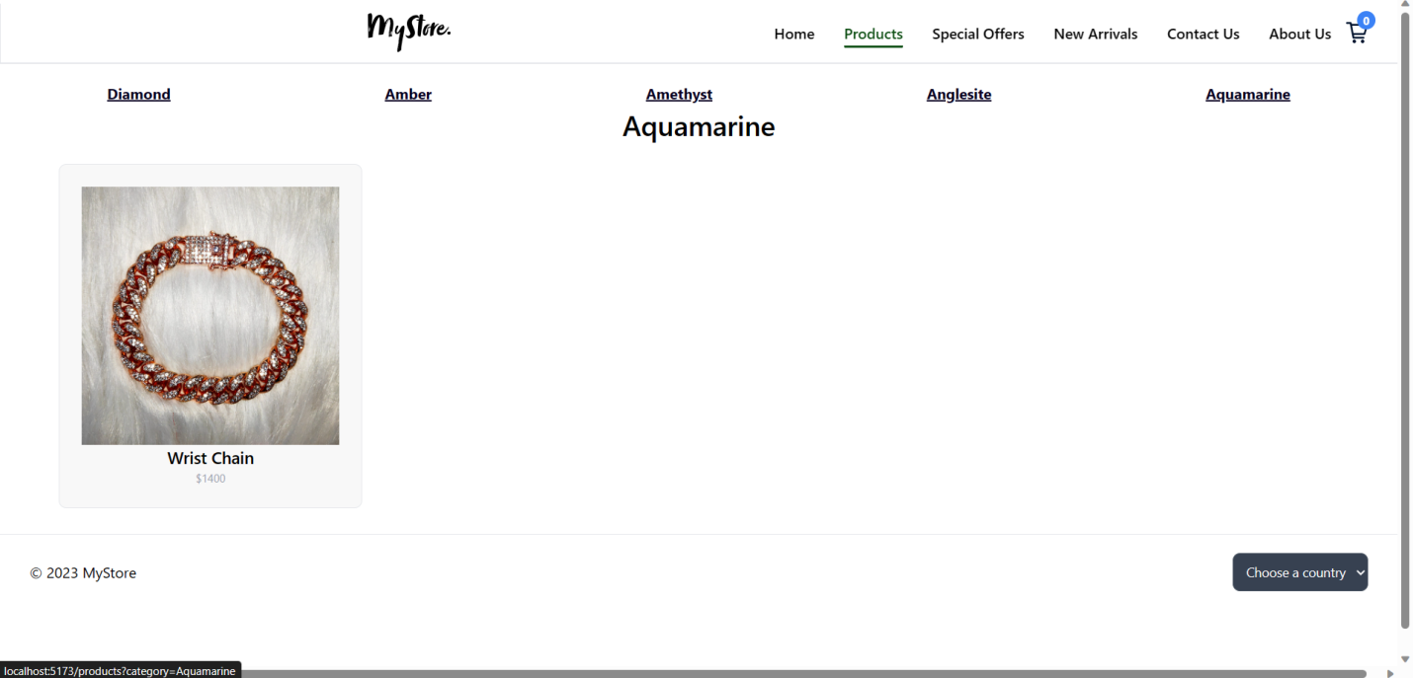

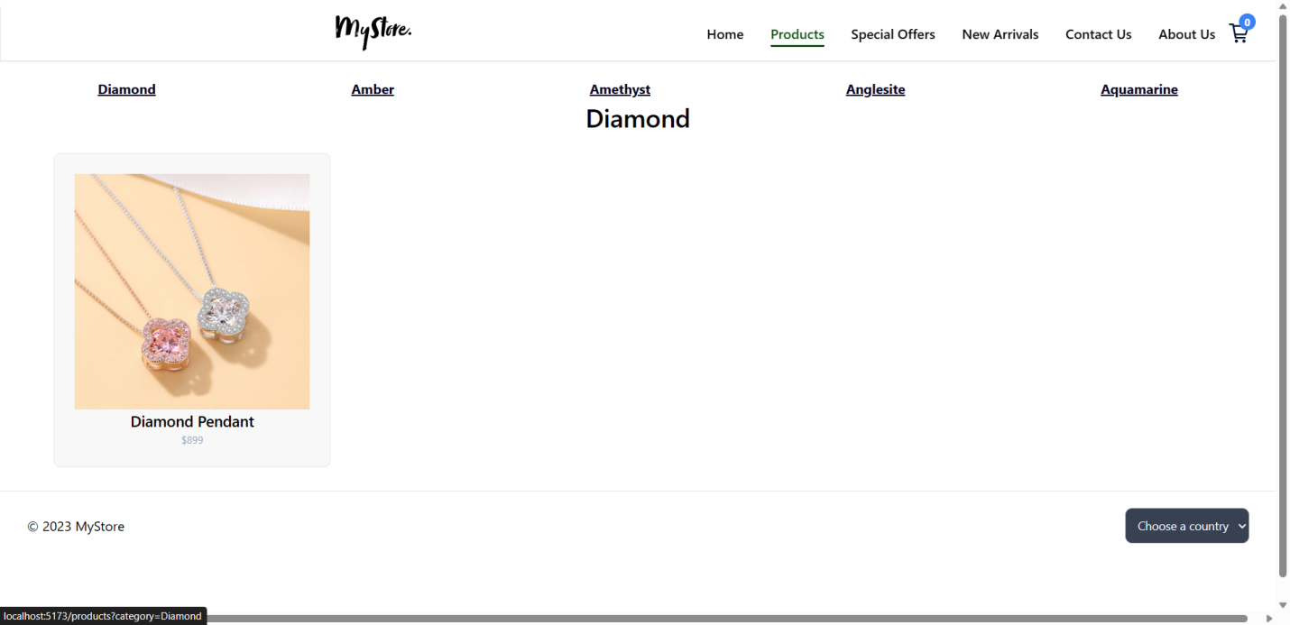

**NEW ARRIVALS PAGE**

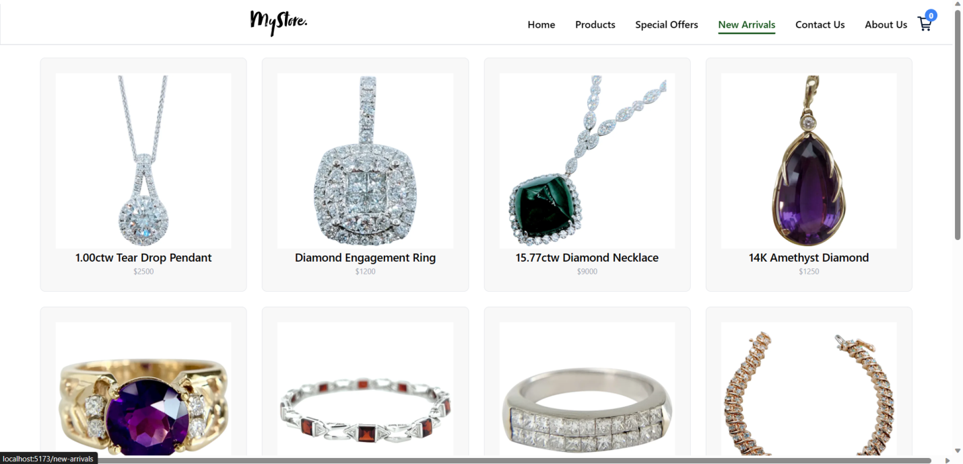

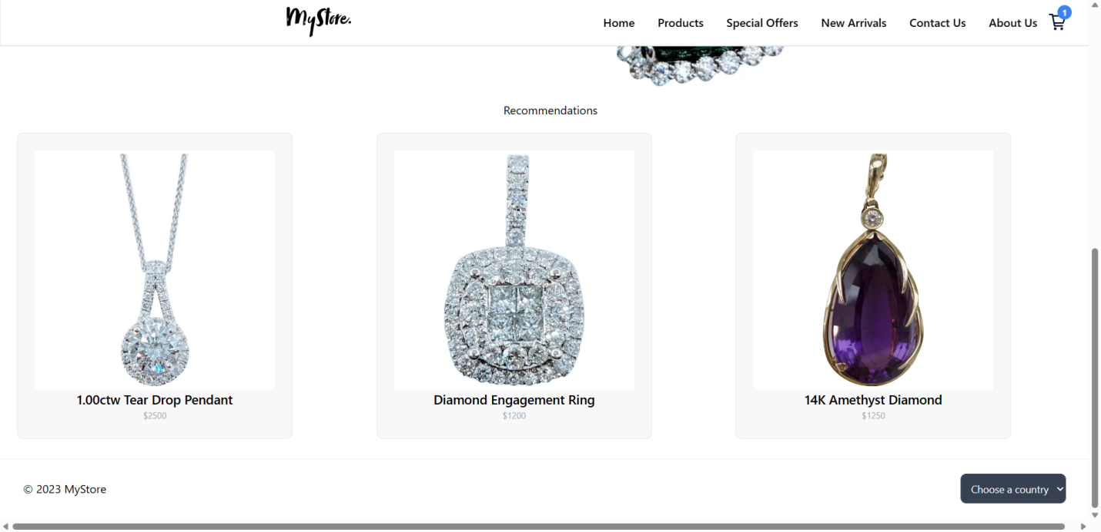

**SPECIAL OFFERS PAGE**

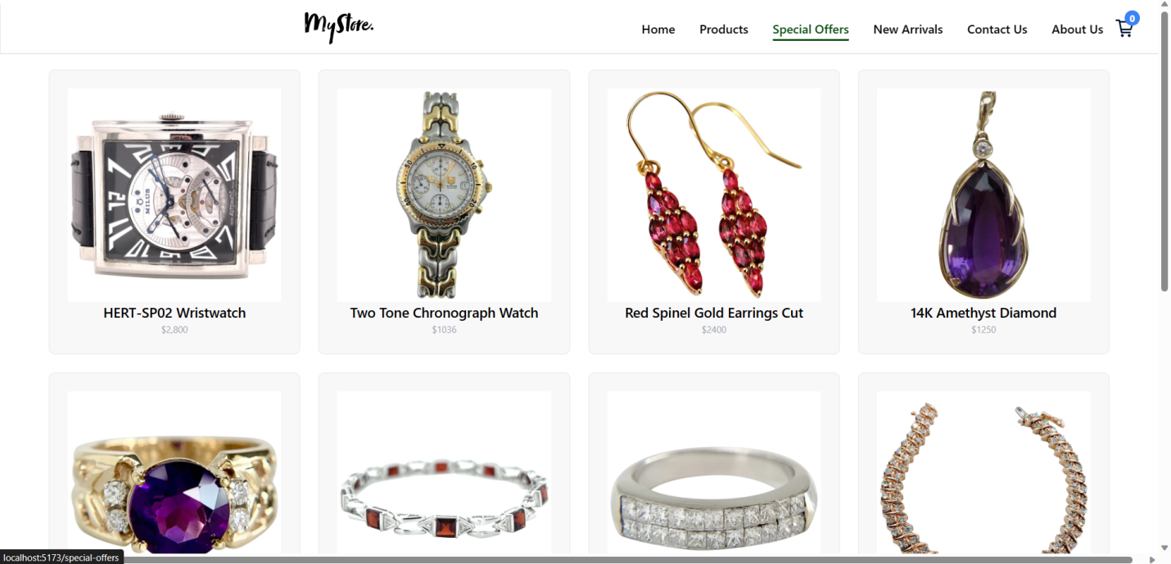

**ABOUT US PAGE**

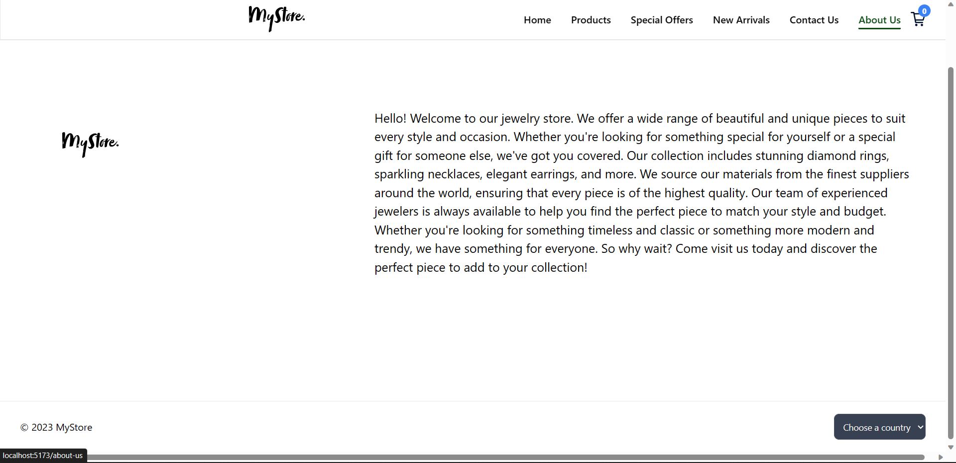

**ORDERING PAGE**

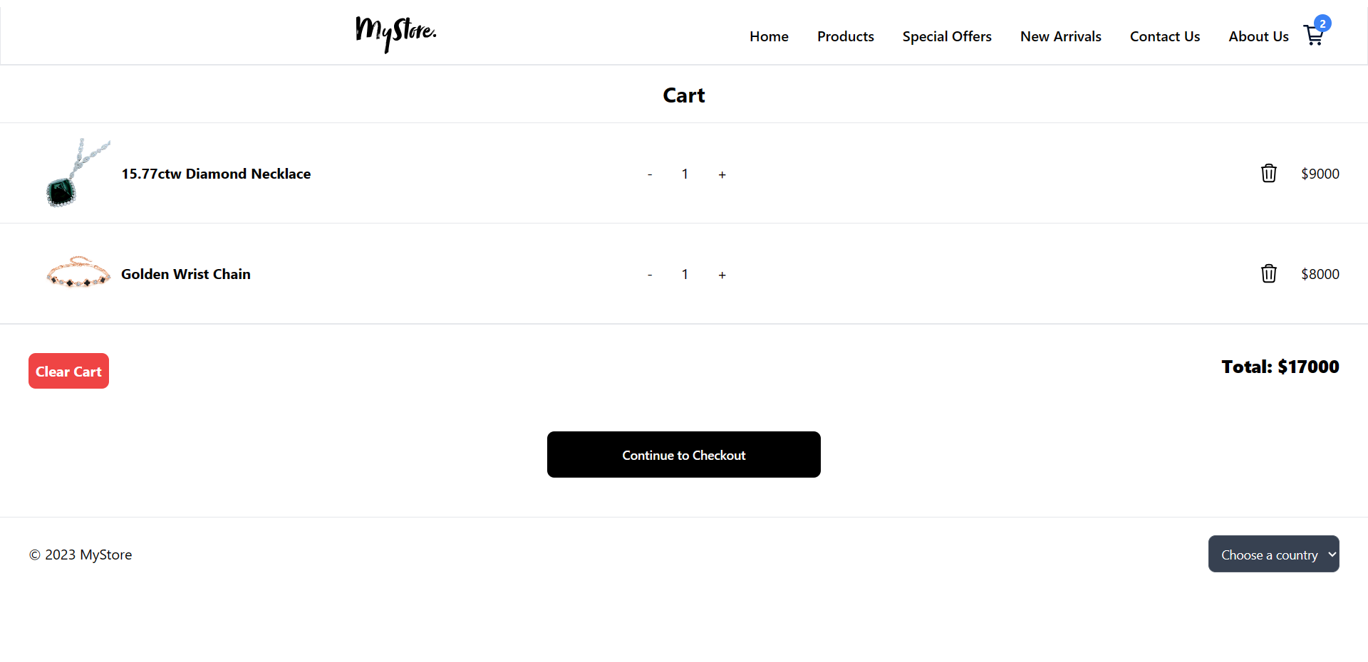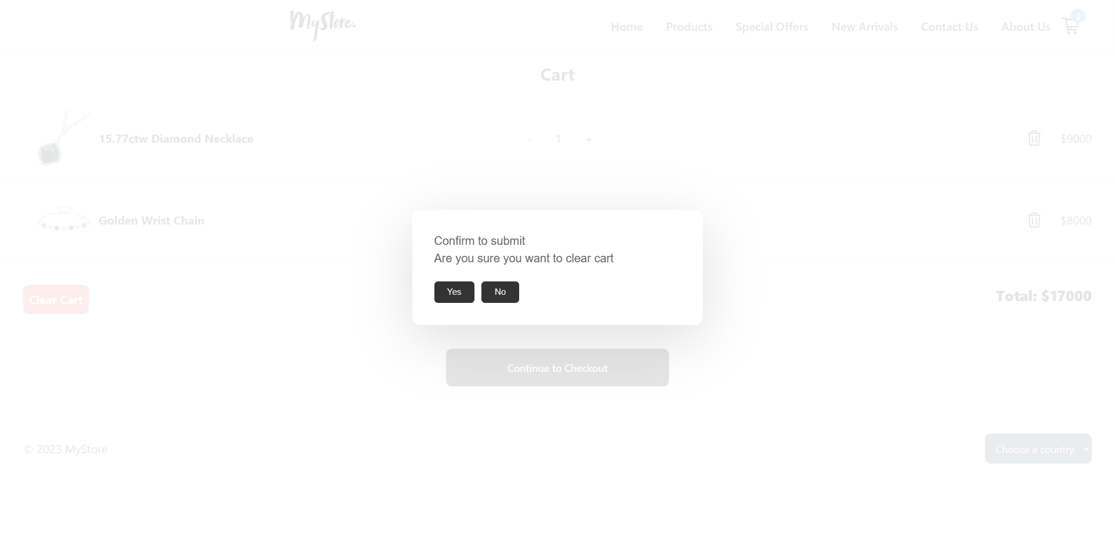

**CONTACT US PAGE**

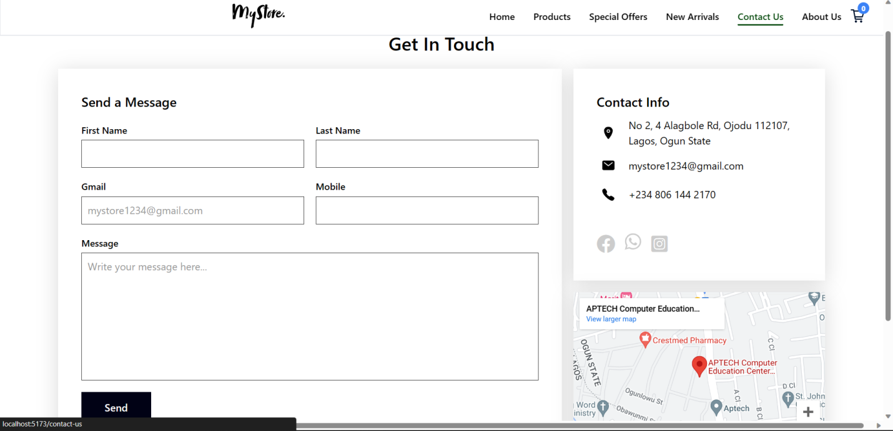

**USER GUIDE**

**Introduction**

Welcome to Crystal Product, a platform for the buying or purchase of our Crystals online. Whether you are a first time user or a season shopper, this guide will help you navigate the site and make the most of the features.

**Getting Started**

To start using our online shop, you will need to create an account. This is a simple process that involves providing some basic information, such as:

**Your name,**

**Email address,**

**Mobile number,**

Once you have filled in the following details and successfully placed your order, you will receive an email on the confirmation of your order and everything you need to know concerning the placement of your order and our website.

**Browsing Product**

Our Crystal Product varies on each category you want. We have various and numerous categories to choose from or to place your order for. Each category has its own Crystal product, it’s worth and everything you need to know about the Crystal you’re interested in buying or purchasing.

**Getting Help**

If you have any questions or need assistance, please don’t hesitate to contact us. You can reach us by either email, phone or through the website contact us form.

**Conclusion**

We hope this guide has been helpful in getting you started with Crystal Product. Whether you are shopping for yourself or others, we are confident you will find everything you need on our site.

**DEVELOPER’S GUIDE**

**Introduction**

Welcome to Crystal Product developer guide. This guide is designed to help the developers to understand how to build application on the Crystal Product platform. Whether you are a season developer or just starting out, this guide will provide the information you need to get started.

**Getting Started**

Before you can start building on the Crystal Product application, you will need to sign up an account and familiarize yourself with the platform architecture and features. You will need to have a basic understanding and knowledge of web development which includes HTML, CSS, JavaScript, Bootstrap and ReactJS.

**Developing Application**

Once you have a basic understanding and knowledge of the platform architecture, you can start building your own application. My web app provide a varieties of tools and the resources to help you along the way including documentation, code samples, and a supportive community of developers.

**Getting Help**

If you have any questions or need assistance, please don’t hesitate to reach out to our support team. You can reach us by email, phone, or through the website contact us form.

**Conclusion**

We hope this guide has been helpful in getting you started with Crystal Product app. Whether you are building your first application or a season developer, we are confident you will find everything you need on our platform to succeed.

**FLOW CHART**

